<!DOCTYPE html>

<html>

<head>

<title>Day 2 of my Challenge</title>

</head>

<body>

<h1> Attributes

DAY 3

DAY 4

DAY 5

DAY 6

<!DOCTYPE html>

<html>

<head>

<title>Day 6 of my challenge</title>

</head>

<body>

<h1>HTML LINKS</h1>

<a href="https://www.w3schools.com/html/default.asp" target="_blank">W3schools website</a>

<h2>Absolute Link</h2>

<p><a href="https://www.instagram.com/envii_30/">My instagram page.</p></a> <!--On the same page-->

<h2>Relative Link</h2>

<p><a href="www.instagram.com/envii_30/">My instagram page.</p></a> <!--Different Page-->

<h2>Button as a Link</h2>

<button onlclick="document.location=https://www.instagram.com/envii_30/">My Instagram Page</button>

<a href="https://www.instagram.com/envii_30/" title="Follow my page">My Instagram page</a>

</body>

</html>

Day 7

<!DOCTYPE html>

<html>

<head>

<title>Day 7 of my challenge</title>

<style>

a:link{

color:green;

text-decoration:none;

}

a:visited{

color:pink;

text-decoration:none;

}

a:active{

color:yellow;

text-decoration:underline;

}

a:hover{

color:red;

text-decoration:underline;

}

a:link, a:visited {

background-color: #000000;

color: white;

padding: 15px 25px;

text-align: center;

text-decoration: none;

display: inline-block;

}

a:hover, a:active {

background-color: red;

}

</style>

</head>

<body>

<h1>HTML LINK COLORS</h1>

<a href="https://www.w3schools.com/html/default.asp" target="_blank">W3schools website</a>

<p><a href="https://www.instagram.com/envii_30/">My instagram page.</p></a> <!--On the same page-->

<p><a href="www.instagram.com/envii_30/">My instagram page.</p></a> <!--Different Page-->

</body>

</html>

Link Book Mark

<!DOCTYPE html>

<html>

<body>

<p><a href="#C4">Jump to Chapter 4</a></p>

<p><a href="#C10">Jump to Chapter 10</a></p>

<h2>Chapter 1</h2>

<p>This chapter explains ba bla bla</p>

<h2>Chapter 2</h2>

<p>This chapter explains ba bla bla</p>

<h2>Chapter 3</h2>

<p>This chapter explains ba bla bla</p>

<h2 id="C4">Chapter 4</h2>

<p>This chapter explains ba bla bla</p>

<h2>Chapter 5</h2>

<p>This chapter explains ba bla bla</p>

<h2>Chapter 6</h2>

<p>This chapter explains ba bla bla</p>

<h2>Chapter 7</h2>

<p>This chapter explains ba bla bla</p>

<h2>Chapter 8</h2>

<p>This chapter explains ba bla bla</p>

<h2>Chapter 9</h2>

<p>This chapter explains ba bla bla</p>

<h2 id="C10">Chapter 10</h2>

<p>This chapter explains ba bla bla</p>

<h2>Chapter 11</h2>

<p>This chapter explains ba bla bla</p>

<h2>Chapter 12</h2>

<p>This chapter explains ba bla bla</p>

<h2>Chapter 13</h2>

<p>This chapter explains ba bla bla</p>

<h2>Chapter 14</h2>

<p>This chapter explains ba bla bla</p>

<h2>Chapter 15</h2>

<p>This chapter explains ba bla bla</p>

<h2>Chapter 16</h2>

<p>This chapter explains ba bla bla</p>

<h2>Chapter 17</h2>

<p>This chapter explains ba bla bla</p>

<h2>Chapter 18</h2>

<p>This chapter explains ba bla bla</p>

<h2>Chapter 19</h2>

<p>This chapter explains ba bla bla</p>

<h2>Chapter 20</h2>

<p>This chapter explains ba bla bla</p>

<h2>Chapter 21</h2>

<p>This chapter explains ba bla bla</p>

<h2>Chapter 22</h2>

<p>This chapter explains ba bla bla</p>

<h2>Chapter 23</h2>

<p>This chapter explains ba bla bla</p>

</body>

</html>

Day 12

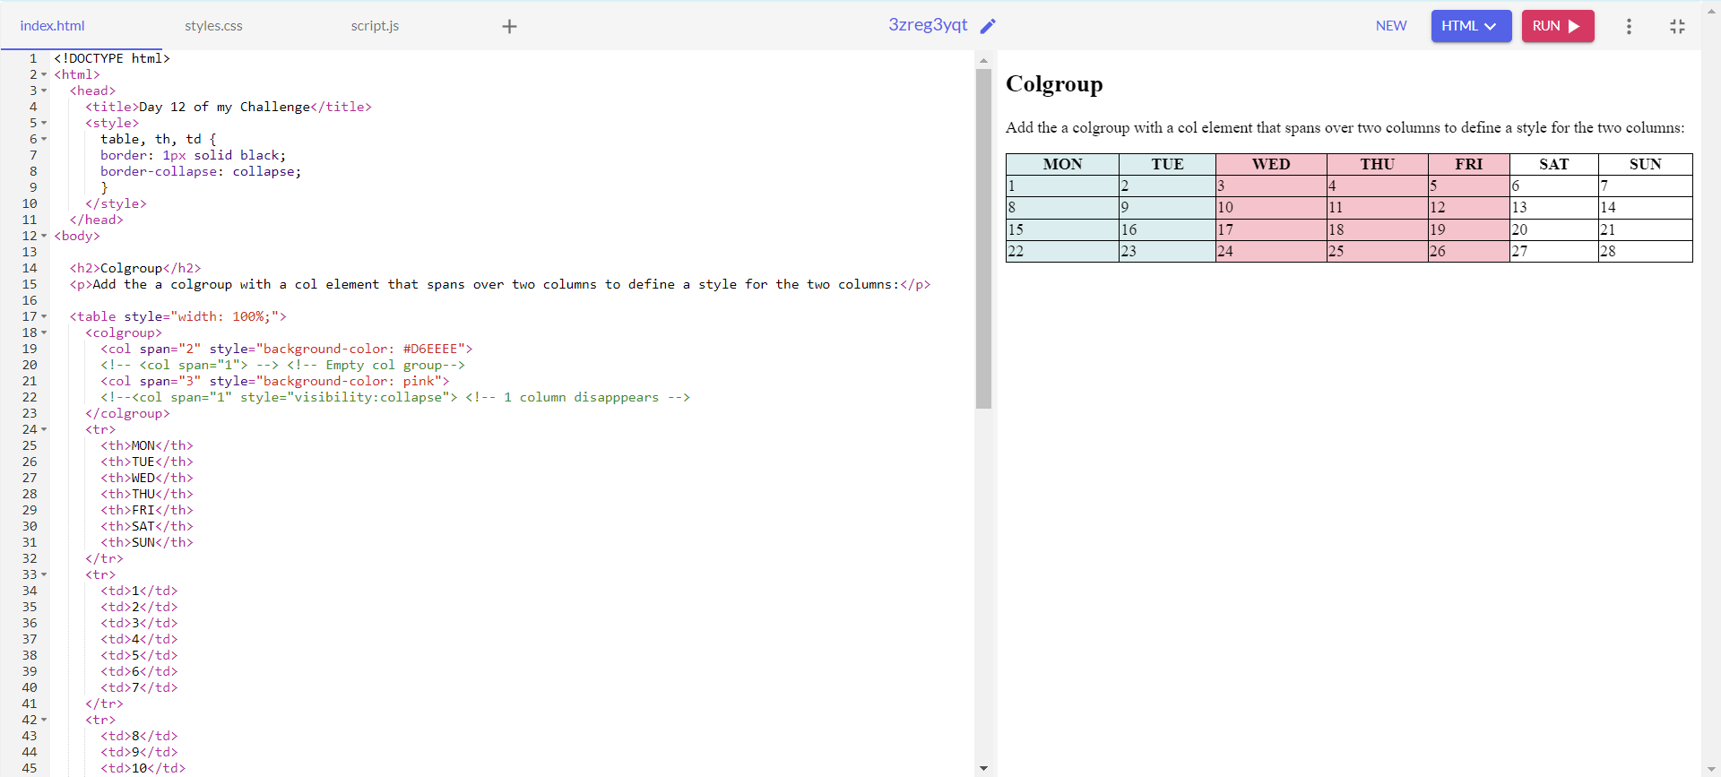

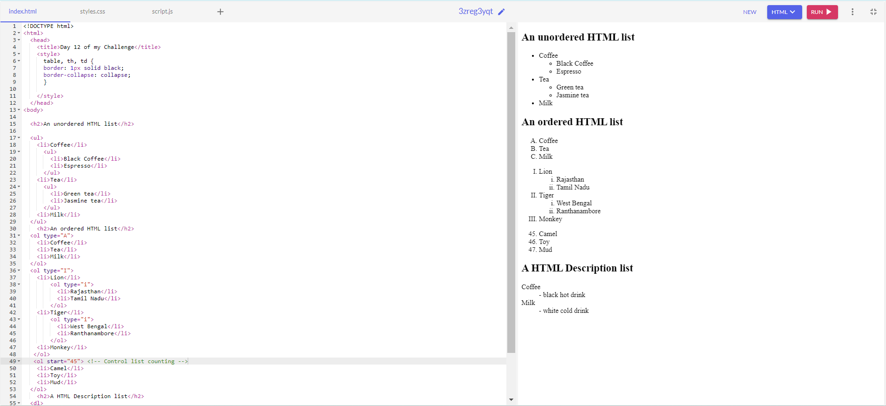

<!DOCTYPE html>

<html>

<head>

<title>Day 12 of my Challenge</title>

<style>

table, th, td {

border: 1px solid black;

border-collapse: collapse;

}

</style>

</head>

<body>

<h2>An unordered HTML list</h2>

<ul>

<li>Coffee</li>

<ul>

<li>Black Coffee</li>

<li>Espresso</li>

</ul>

<li>Tea</li>

<ul>

<li>Green tea</li>

<li>Jasmine tea</li>

</ul>

<li>Milk</li>

</ul>

<h2>An ordered HTML list</h2>

<ol type="A">

<li>Coffee</li>

<li>Tea</li>

<li>Milk</li>

</ol>

<ol type="I">

<li>Lion</li>

<ol type="i">

<li>Rajasthan</li>

<li>Tamil Nadu</li>

</ol>

<li>Tiger</li>

<ol type="i">

<li>West Bengal</li>

<li>Ranthanambore</li>

</ol>

<li>Monkey</li>

</ol>

<ol start="45"> <!-- Control list counting -->

<li>Camel</li>

<li>Toy</li>

<li>Mud</li>

</ol>

<h2>A HTML Description list</h2>

<dl>

<dt>Coffee</dt> <!-- defining the term -->

<dd>- black hot drink</dd> <!-- Describing the term -->

<dt>Milk</dt>

<dd>- white cold drink</dd>

</dl>

</body>

</html>

Day 13

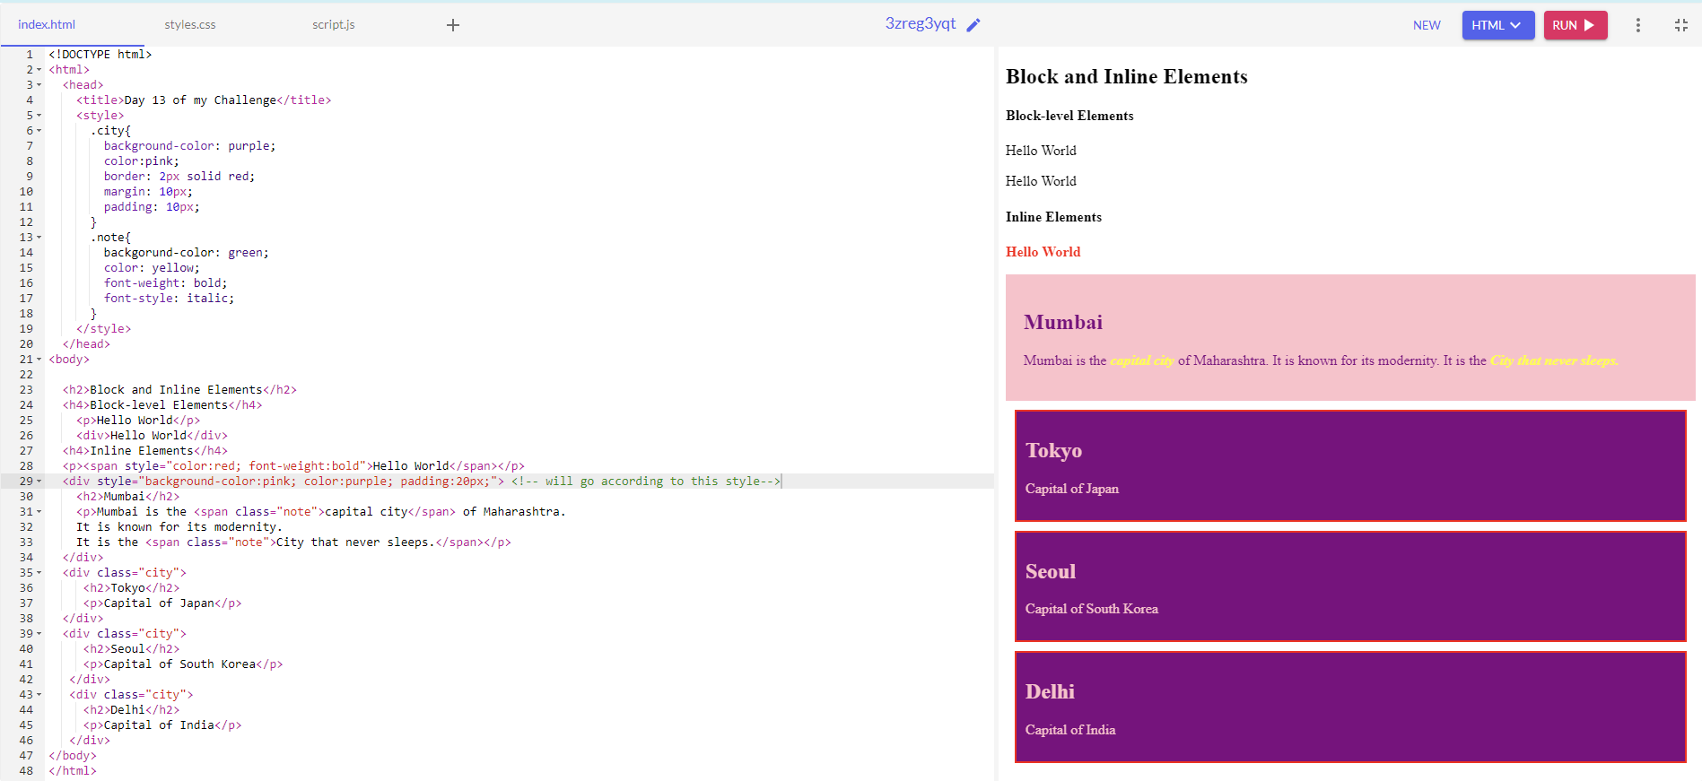

<!DOCTYPE html>

<html>

<head>

<title>Day 13 of my Challenge</title>

<style>

.city{

background-color: purple;

color:pink;

border: 2px solid red;

margin: 10px;

padding: 10px;

}

.note{

backgorund-color: green;

color: yellow;

font-weight: bold;

font-style: italic;

}

</style>

</head>

<body>

<h2>Block and Inline Elements</h2>

<h4>Block-level Elements</h4>

<p>Hello World</p>

<div>Hello World</div>

<h4>Inline Elements</h4>

<p><span style="color:red; font-weight:bold">Hello World</span></p>

<div style="background-color:pink; color:purple; padding:20px;"> <!-- will go according to this style-->

<h2>Mumbai</h2>

<p>Mumbai is the <span class="note">capital city</span> of Maharashtra.

It is known for its modernity.

It is the <span class="note">City that never sleeps.</span></p>

</div>

<div class="city">

<h2>Tokyo</h2>

<p>Capital of Japan</p>

</div>

<div class="city">

<h2>Seoul</h2>

<p>Capital of South Korea</p>

</div>

<div class="city">

<h2>Delhi</h2>

<p>Capital of India</p>

</div>

</body>

</html>

Day 14

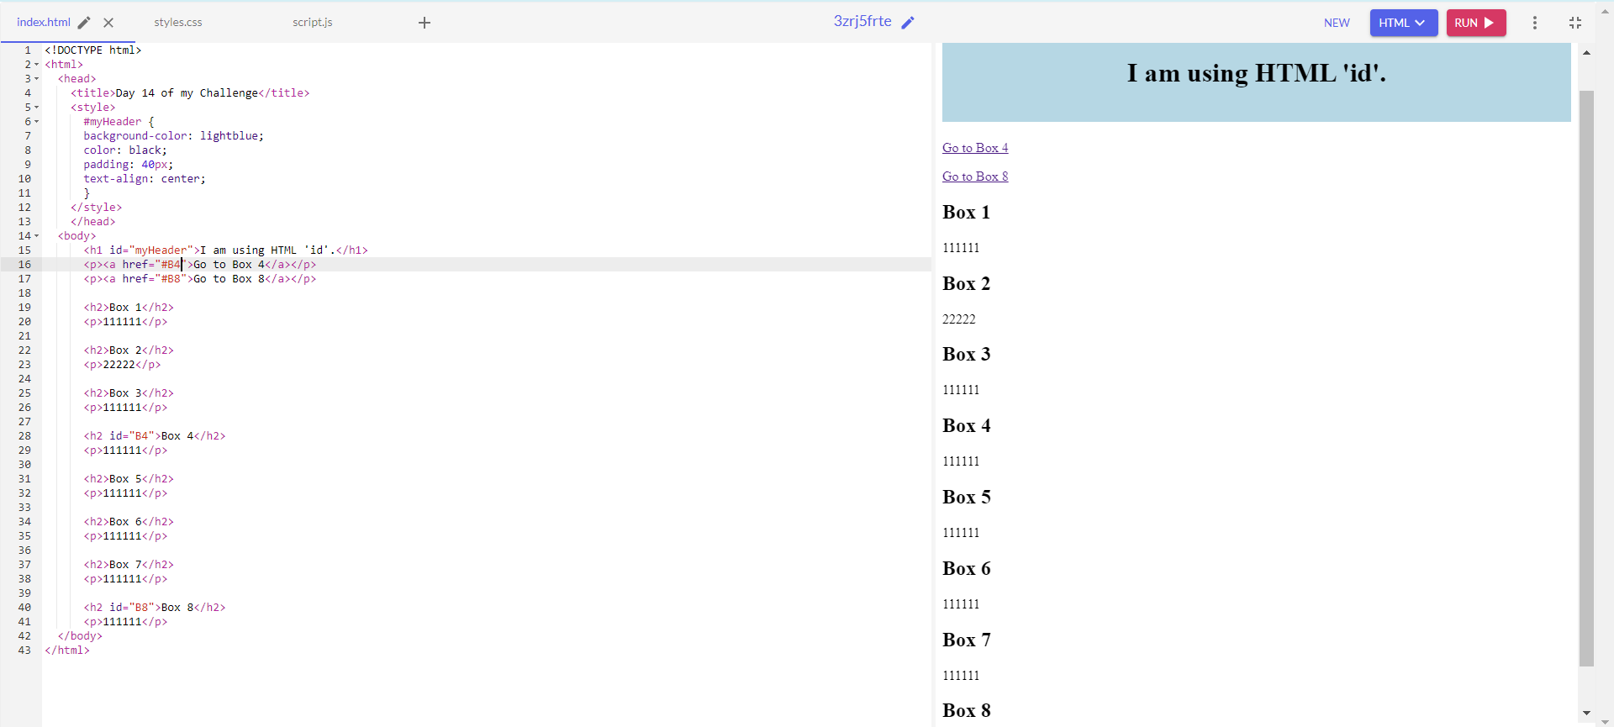

Day 15

<!DOCTYPE html>

<html>

<head>

<title>Day 15 of my Challenge</title>

</head>

<body>

<iframe src="https://www.instagram.com/envii_30/" styel="height:200px;width:100px;" title="My Instagram Page"></iframe>

</body>

</html>

Day 17

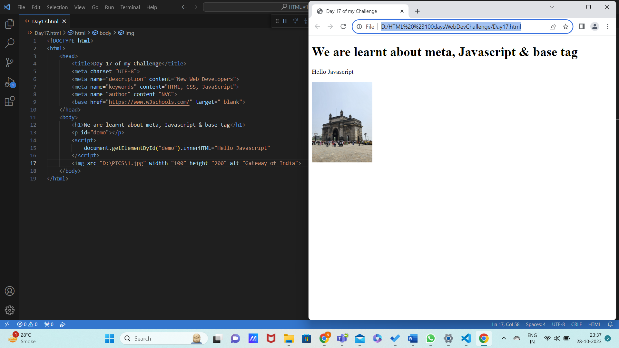

Day 20



